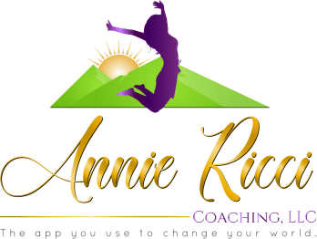

Jumping In

Welcome to Coaching!
I am excited and honored to be on this journey with you. The questions and forms in this packet will be our jumping off point. I have discovered that spending some time in thoughtful reflection helps clients experience deeper growth through the coaching process. My job as a Coach is to help you identify and refine your goals, eliminate the barriers that stand in your way, and help you take the action to make those outcomes your realities. I’ll be keeping an eye on both your long-term “meta-goals” as well as the weekly and monthly steps that will help you get what you want.
Below are some brief instructions for the forms herein.

Introduction – Jumping In
Please complete and send a copy of this form prior to your first session

Please take some time to answer the questions. Some of the questions may be easier to answer than others. Take as much space answering as you like! Reflecting on your life and/or profession is a good place to start when you are about to transform either. The purpose of Coaching is to develop and implement strategies to help you reach your goals. Coaching may address a wide variety of goals including specific personal projects, life balance, job performance and satisfaction or general conditions in your business or personal life.

Your Life Up to Now
- What would you say have been your 3 greatest accomplishments to date?

- What do you see as your ‘craft’ or an area of true mastery?

- What major transitions have you had in the past two years? (Entering or approaching a new decade, a new relationship, a new job, a new role, a new residence, change in children’s ages/stages, etc.)

- Who are the people in your life that track with you and will support you as you move through change?

Potential and Possibility
- Do you have a personal or professional vision? If so, please write a little about it.

- What are your aspirations at this point in life?

- If you reach the age of 95 and continue to live your life and order your time the way you are right now, what regrets do you think you will have? Do not include things from
the past – only things you will regret if you continue your exact present path.

- What else is important for us to look at during our time together?

